MACHINE LEARNING MODEL DEVELOPMENT
AND EVALUATION
Week 4 Internship Task
Titanic Survival Prediction using Logistic Regression

Prepared using Python, Pandas, Scikit-learn, Matplotlib and Seaborn

1. Executive Summary
This report documents an end-to-end machine learning workflow for predicting passenger survival in the Titanic dataset. The analysis covers data loading, validation, feature selection, categorical encoding, train-test splitting, model training, prediction, quantitative evaluation, visual analysis, error analysis, and a brief assessment of overfitting and model limitations. A Logistic Regression classifier was selected because the target variable is binary (survived/not survived) and the algorithm provides a clear, interpretable baseline for classification.
The notebook contains 781 observations and 15 original columns. For modelling, eight input variables were retained: pclass, sex, age, sibsp, parch, fare and encoded embarked categories. The final test set contained 157 observations. The trained model achieved 78.34% testing accuracy, 72.46% precision, 76.92% recall, 74.63% F1-score and a ROC-AUC of 0.854. Training accuracy was 77.56%, compared with 78.34% testing accuracy, so the recorded results do not show a large training-to-testing performance gap.

2. Objective
The objective was to develop and evaluate a basic supervised machine learning model using a real-world dataset. The workflow was designed to demonstrate practical understanding of preprocessing, feature preparation, model training, prediction and evaluation metrics, while also identifying sources of error and possible improvements.

3. Dataset and Data Preparation
The notebook loaded a cleaned Titanic CSV file. The loaded dataset contained 781 rows and 15 columns. Initial inspection showed no missing values across the retained dataset and no duplicate rows. Descriptive statistics were generated before modelling to understand the numerical variables.
Item | Value | Purpose
Dataset size | 781 rows × 15 columns | Initial dataset structure
Missing values | 0 in all columns | Data quality validation
Duplicate rows | 0 | Duplicate check
Selected modelling inputs | 8 | Compact feature set
Target variable | survived | Binary classification target

4. Feature Selection and Preprocessing
For the modelling stage, the target variable was separated from the predictors. The selected predictors were pclass, sex, age, sibsp, parch, fare and embarked. The categorical variables sex and embarked were transformed using one-hot encoding with the first category dropped. This produced eight numerical/binary model features. The resulting feature matrix had 781 rows and 8 columns.
Selected model features:
- pclass
- age
- sibsp
- parch
- fare
- sex_male
- embarked_Q
- embarked_S

5. Train-Test Design
The dataset was divided into training and testing subsets using an 80:20 split, random_state=32, with stratification by the target variable. This produced a training set of approximately 80% of the observations and a test set of 157 observations. Stratification was used to preserve the target-class distribution between the two subsets.

6. Model Selection and Training
Logistic Regression was selected as the baseline classification algorithm. It is appropriate for a binary target and provides an interpretable set of coefficients that can be inspected to understand the direction of association between the input features and the model's predicted class.
Model configuration: LogisticRegression(max_iter=1000). The model was fitted on the training data and then used to predict the test set.

7. Model Evaluation Results
Metric | Result | Interpretation
Training Accuracy | 77.56% | Performance on training data
Testing Accuracy | 78.34% | Overall test classification accuracy
Precision | 72.46% | Positive predictions that were correct
Recall | 76.92% | Positive cases identified by the model
F1 Score | 74.63% | Balance of precision and recall
ROC-AUC | 0.854 | Discrimination across probability thresholds

8. Classification Report
The classification report in the notebook shows class-specific performance. For class 0, precision was 0.83, recall 0.79 and F1-score 0.81 on 92 test observations. For class 1, precision was 0.72, recall 0.77 and F1-score 0.75 on 65 observations. Overall accuracy was 0.78 on 157 test observations.

9. Confusion Matrix Analysis
The confusion matrix contained 73 true negatives, 19 false positives, 15 false negatives and 50 true positives. These values show that the model correctly classified 123 of the 157 test observations, while 34 observations were misclassified.
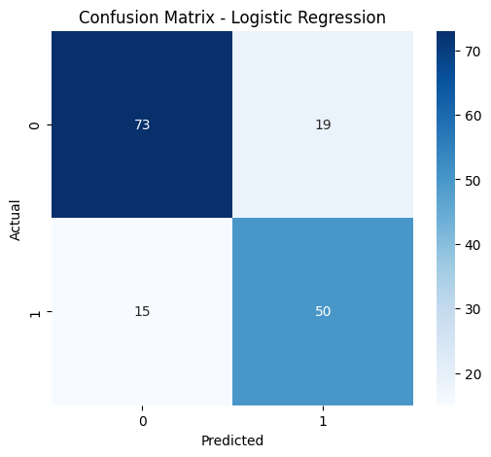
Figure 1. Confusion Matrix — Logistic Regression

10. ROC Curve Analysis
The ROC curve summarizes the model's ability to distinguish between the two target classes across different classification thresholds. The notebook recorded a ROC-AUC of 0.8535 (approximately 0.854).
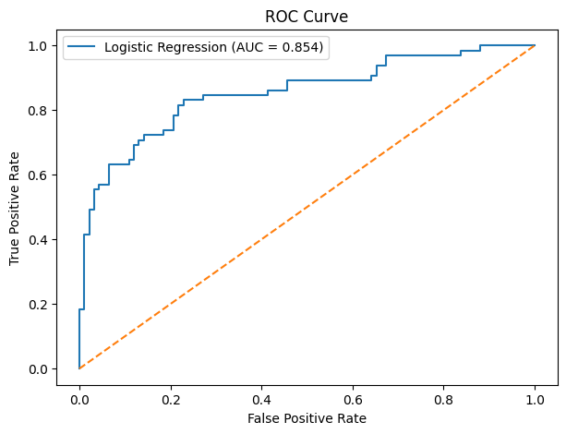
Figure 2. ROC Curve and ROC-AUC

11. Performance Comparison
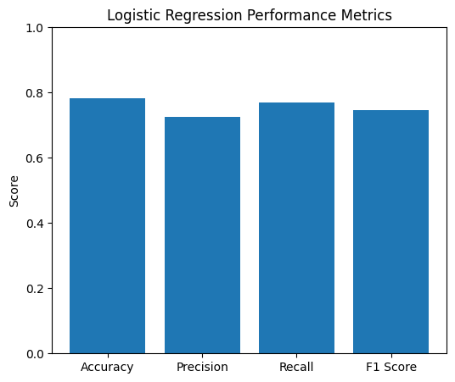
Figure 3. Accuracy, Precision, Recall and F1-score
The performance chart provides a compact comparison of the main classification metrics. Accuracy is the highest of the four reported threshold-based metrics, while precision is lower than recall, indicating that the model identified more of the actual positive cases than the proportion of positive predictions that were correct.

12. Actual vs Predicted Analysis
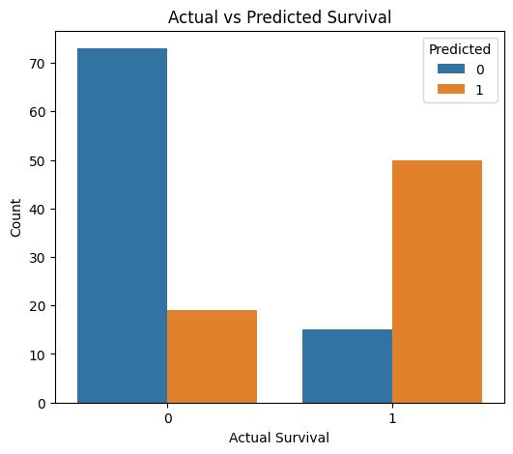
Figure 4. Actual versus Predicted Survival Counts

13. Feature Coefficient Analysis
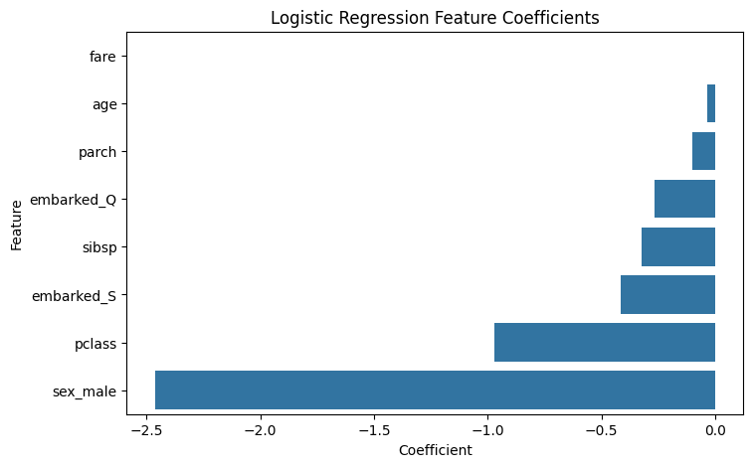
Figure 5. Logistic Regression Feature Coefficients
The fitted coefficients provide an interpretable view of the model. In the notebook, sex_male had the largest negative coefficient (-2.464), followed by pclass (-0.972). Fare had a small positive coefficient (0.0014), while age (-0.0337), parch (-0.0983), sibsp (-0.3236), embarked_Q (-0.2677) and embarked_S (-0.4148) had negative coefficients. These are model coefficients, not causal effects.

14. Error Analysis
- True Negatives (TN): 73
- False Positives (FP): 19
- False Negatives (FN): 15
- True Positives (TP): 50
The 19 false positives represent observations predicted as the positive class when the actual class was 0, while the 15 false negatives represent positive cases that the model missed. Such errors are expected in a real-world classification problem and indicate that the selected features do not perfectly separate the two classes.

15. Overfitting and Underfitting Assessment
The recorded training accuracy was 77.56% and testing accuracy was 78.34%. The testing score is slightly higher than the training score in this particular split, so the notebook does not show a large train-test performance gap that would directly indicate severe overfitting. However, a single train-test split is not sufficient to establish generalization performance with certainty. Cross-validation would provide a more robust estimate.

16. Strengths of the Model
- Simple and computationally efficient baseline classification approach.
- Produces interpretable coefficients for the selected features.
- Uses stratified train-test splitting to maintain target-class proportions.
- Evaluation includes accuracy, precision, recall, F1-score, confusion matrix and ROC-AUC.
- Testing ROC-AUC of approximately 0.854 indicates useful class-discrimination ability on this test split.

17. Limitations and Potential Sources of Error
- The model uses a limited set of selected variables and may omit useful information present in the original dataset.
- One train-test split can make performance estimates sensitive to the particular random split.
- Categorical encoding and linear decision boundaries may not capture all nonlinear relationships.
- False positives and false negatives remain, as shown by the confusion matrix.
- Model coefficients describe the fitted model and should not be interpreted as proof of causation.

18. Suggested Improvements
- Use k-fold cross-validation for more stable performance estimates.
- Compare Logistic Regression with Decision Tree, Random Forest and other suitable classifiers.
- Perform hyperparameter tuning and evaluate the effect on test performance.
- Explore additional meaningful features and feature engineering.
- Use a separate validation strategy when comparing multiple candidate models.
- Evaluate calibration and threshold selection if probability-based decisions are important.

19. Conclusion
This Week 4 project demonstrates a complete introductory machine learning pipeline using the Titanic dataset. The Logistic Regression model achieved 78.34% testing accuracy, 74.63% F1-score and 0.854 ROC-AUC on the recorded test split. The confusion matrix showed 123 correct classifications and 34 misclassifications. The training and testing accuracies were close, with testing accuracy slightly higher in this split. Overall, the exercise demonstrates practical skills in preprocessing, feature encoding, model training, evaluation, visualization and critical discussion of model limitations. Further model comparison and cross-validation would be appropriate next steps for a more robust assessment.

20. Reproducibility and Tools
- Python
- Google Colab / Jupyter Notebook
- Pandas and NumPy
- Scikit-learn
- Matplotlib
- Seaborn
- Titanic cleaned dataset

